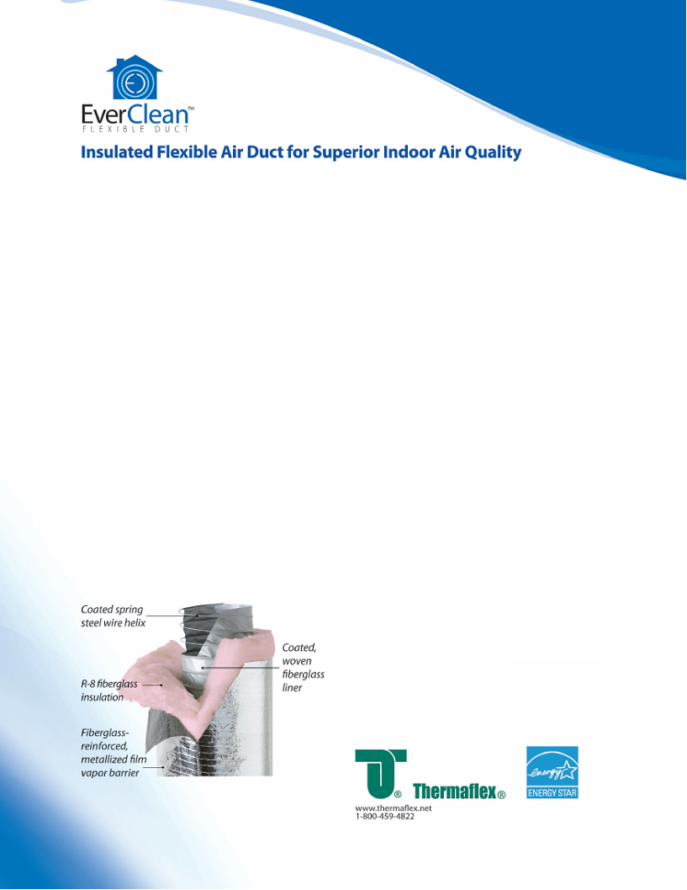
- EverClean product is Greenguard Certified for Indoor Air Quality
- EverClean product is Greenguard certified for Children and Schools
- EverClean offers a lifetime warranty with all cost inclusive replacement including labor.
- EverClean Certified mold and mildew resistant by ASTM Guideline D 6329-98
- EverClean core constructed of heavy coated fiberglass cloth material that will not burn.
- Coated spring steel wire reinforcement for superior strength and durability.
- EverClean performance
  - 16” wc pos 4”-10” dia’s
  - 2” wc pos 12-20” dia’s
  - 2” negative all dia’s
  - 6,000 FPM velocity

- AMBlue product has not been tested and certified by AQS to qualify for Greenguard Certification. Only the fiberglass used in this product from OC is certified which is not exposed to the air space.
- AMBlue offers a 10 year warranty on duct replacement only.
- AM Blue Certified mold and mildew resistant by AATCC Test Method 30 and 147.
- AM Blue core constructed with a thin co-extruded nylon film.
- AMBlue performance
  - 3” wc pos 4”-12” dia’s
  - 2” wc pos 14-20” dia’s
  - 1” negative 4”- 10” dia’s
  - ½” negative 12” 20” dia’s
  - 4,000 FPM Velocity
- Wer

